Measure and compare canal transportation and centering ratio of WaveOne GOLD, Reciproc Blue and TwoShape file systems using Cone Beam Computed Tomography and exporting images into Adobe photoshop software

¹Sandya Rani Kollabathula, ²Lavanya Dharmana, ³Gosala Bindu Madhavi, ⁴Mounika Anukolu, ⁵Ramakrishna Raju
¹Department of Conservative Dentistry and Endodontics, GSL Dental College, Rajahmahendravaram, Andhra Pradesh, India(Corresponding Author)
²Assistant Professor, Department of Dentistry, Andhra Medical College, Visakhapatnam, Andhra Pradesh, India
³Department of Conservative Dentistry and Endodontics, GSL Dental College and Hospital, Rajahmahendravaram, Andhra Pradesh, India
⁴Department of Conservative Dentistry and Endodontics, GSL Dental College and Hospital, Rajahmahendravaram, Andhra Pradesh, India
⁵Head of the Department Conservative Dentistry and Endodontics, GSL Dental College and Hospital Rajahmahendravaram, Andhra Pradesh, India

Abstract:
Background: To measure and compare canal transportation and centering ratio of WaveOne GOLD, Reciproc Blue and TwoShape file systems using Cone Beam Computed Tomography and exporting images into Adobe photoshop software. Materials & Methods: Sixty tooth samples were randomly divided into three groups. Wave One Gold Group, Reciproc blue Group and Two-Shape Group containing twenty tooth samples in each group. Wave One Gold and Reciproc blue group operated in reciprocating motion. Two-Shape group operated in continuous motion. All the observed values were noted and statistical analysis was done using IBM SPSS Version 20 software (IBM Corp., Armonk, NY, USA). Results: The comparison of canal transportation between the study groups at various levels and the results are statistically insignificant. There were no significant differences in canal transportation between groups at any of the levels studied. At level 7, less canal transportation was observed in the 2 Shape group (0.091) compared to Wave One Gold (0.093) and Reciproc Blue (0.1). Conclusion: WaveOne Gold showed better centering and less canal transportation than Reciproc blue and 2 Shape. Least centering and more transportation was observed with 2 Shape file system.
Keywords: Waveone gold, Twoshape, Reciproc blue.

Introduction:
Biomechanical preparation was one of major components of endodontic treatment. It is associated with successive steps of disinfection and filling. Goal of endodontic treatment is to create continuously tapering form with smallest diameter at the apex and the largest at the orifice for effective filling and irrigation. ¹ Mechanical instrumentation was one of most important procedure in endodontics. It was also treated as the most difficult challenge. Biomechanical preparation should be accompanied by thorough irrigation of root canals, it is referred to as ‘cleaning and shaping’, many authors suggest that ‘shaping and cleaning’ is more appropriate. Root canal Preparation had been described in literature since 18th century no preparation sequence appeared till 1961. Later instrumentation done by stainless steel files and reamers. ²
In majority of cases single file is used to complete root canal treatment so there is reduced number of instruments for cleaning and shaping. It reduces possible contamination and relieves operator anxiety of possible instrument failure and also reduces the preparation time. ³ WaveOne Gold (WOG) instruments undergo post manufacturing thermal process, producing super-elastic NiTi files which are heat treated and cooled slowly improving the flexibility and strength. WOG primary file is 23% more efficient 50% more resistant to cyclic fatigue, 80% more flexible. WOG files had a parallelogram off-centred, cross section (Webber, 2015). According to Ruddle, at any given cross section it limits engagement between the file and dentin to only one or two contact points. This will reduce taper lock and the screw-effect, which improve safety and cutting efficiency. ⁴ Two-Shape is made of T-wire heat-treated file with an asymmetric triangular cross-section. The 2S system is composed of TS1: (25/.04). TS2: (25/.06), F35 (36/.06), and F40 (40/.04) files. It had latest generation of cross-section with two main cutting edges for cutting efficiency and one secondary edge improving the removal of debris. ⁵ Shaping ability and canal transportation were evaluated by many strategies. Comparing pre- and post-instrumentation canal shape by CBCT is recent, non-invasive diagnostic technique with low-dose radiation. ⁶ Hence, this study was conducted to measure and compare canal transportation and centering ratio of WaveOne GOLD, Reciproc Blue and TwoShape file systems using Cone Beam Computed Tomography and exporting images into Adobe photoshop software.
Materials & Methods:
Sixty tooth samples were randomly divided into three groups. Wave One Gold Group, Reciproc blue Group and Two-Shape Group containing twenty tooth samples in each group. Wave One Gold and Reciproc blue group operated in reciprocating motion. Two-Shape group operated in continuous motion. Pre and post instrumentation images of Canal Centering and canal transportation were measured and images imported into Adobe photoshop software. All the observed values were noted and statistical analysis was done using IBM SPSS Version 20 software (IBM Corp., Armonk, NY, USA). Descriptive statistics, Kruskal Wallis Analysis of Variance, and Friedman’s tests were done to analyse the study data. P≤0.05 was regarded as statistically significant.
Results:
The comparison of canal transportation between the study groups at various levels and the results are statistically insignificant. There were no significant differences in canal transportation between groups at any of the levels studied. However, less canal transportation was observed with Wave One Gold at levels 3 and 5 (.075, 0.077, respectively) followed by Reciproc Blue (0.078, 0.098, at levels 3 and 5, respectively) and 2 Shape (0.149, 0.188 at levels 3 and 5, respectively). At level 7, less canal transportation was observed in the 2 Shape group (0.091) compared to Wave One Gold (0.093) and Reciproc Blue (0.1).

Table 1: Comparison of canal transportation between the study groups at various levels.
Level | Group |  | N | Mean |  | SD |  |  | 95% confidence interval for mean |  |  |  | Mean rank |  | P-value
 |  |  |  |  |  |  |  |  | Lower bound |  | Upper bound
3 | Wave one gold |  | 20 | 0.075134 |  | 0.332016 |  |  | 0.23208 |  | 0.08197 |  | 25.58 |  | 0.252
 | Reciproc blue |  | 20 | 0.078412 |  | 0.272133 |  |  | 0.049119 |  | 0.206 |  | 31.28
 | 2 shape |  | 20 | 0.149001 |  | 0.471019 |  |  | 0.071902 |  | 0.37189 |  | 34.65
5 | Wave one gold |  | 20 | 0.077234 |  | 0.189133 |  |  | 0.166241 |  | 0.01322 |  | 25.6 |  | 0.168
 | Reciproc blue |  | 20 | 0.098213 |  | 0.254162 |  |  | 021428 |  | 0.02004 |  | 29.93
 | 2 shape |  | 20 | 0.188762 |  | 0.284068 |  |  | 0.32147 |  | 0.05228 |  | 35.98
7 |  | Wave one gold | 20 |  | 0.093018 |  | 0.131244 | 0.15168 |  | 0.002122 |  | 30.4 |  | 0.541
 |  | Reciproc blue | 20 |  | 0.109324 |  | 0.172389 | 0.21462 |  | 0.003146 |  | 33.3
 |  | 2 shape | 20 |  | 0.091804 |  | 0.098264 | 0.290081 |  | 0.00932 |  | 27.8
Kruskal Wallis ANOVA; p≤0.05 considered statistically significant
Intra group comparison revealed that 2 shape at level 5 showed more centering ability (0.662) however 2 Shape showed least centering ability at 7mm (0.512). Reciproc blue at level 5 showed more centering ability (0.754) however Reciproc blue showed least centering ability at 3mm (0.484). WaveOne Gold at level 5 showed more centering ability (0.77), and least centering ability was shown at 3mm (0.528).
Table 2: Comparison of centering ability within each of the study groups at a given level
Group | Level | N | Mean | SD |  | 95% confidence interval for mean |  |  | Mean rank | P-value
 |  |  |  |  |  | Lower bound |  | Upper bound
Wave one gold | 3 | 20 | 0.528114 | 1.5341 |  | 0.3711 |  | 1.03524 | 25.95 | 0.71
 | 5 | 20 | 0.773200 | 1.14321 |  | 0.24209 |  | 1.31006 | 27.65
 | 7 | 20 | 0.618246 | 0.54239 |  | 0.36439 |  | 0.87096 | 26.42
Reciproc blue | 3 | 20 | 0.484226 | 3.46289 |  | 0.21228 |  | 3.45249 | 25.14 | 0.428
 | 5 | 20 | 0.754124 | 0.844002 |  | 0.019738 |  | 1.17346 | 28.2
 | 7 | 20 | 0.596001 | 6.0912 |  | 0.26588 |  | 4.43862 | 26.22
2 shape | 3 | 20 | 0.534014 |  | 2.06014 |  | 0.14278 | 1.79102 | 25.22 | 0.336
 | 5 | 20 | 0.662001 |  | 1.89163 |  | 0.75426 | 1.0225 | 28.92
 | 7 | 20 | 0.512006 |  | 3.11866 |  | 0.61397 | 1.30523 | 26.06

NT USED
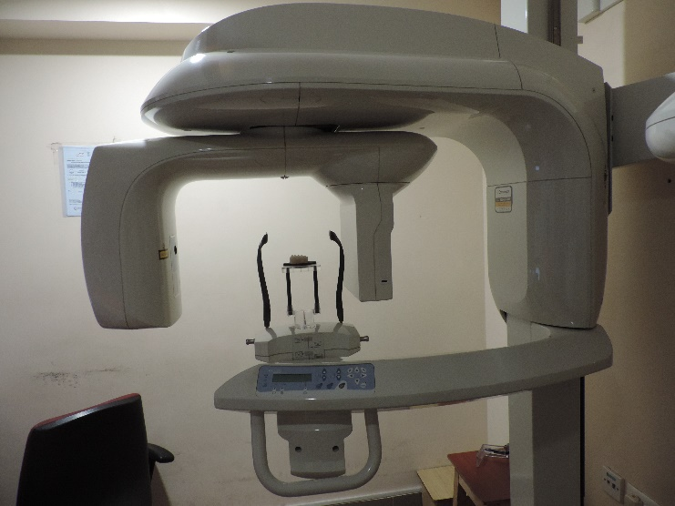
Fig. 1: Cone Beam Computed Tomography
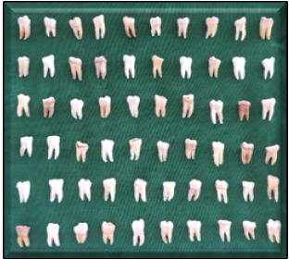 Fig. 6 Collected test sample teeth
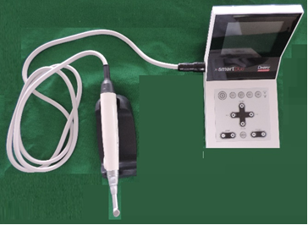
Fig. 11 X Smart Plus Endo motor
GROUP 1: Wave One Gold (n=20)
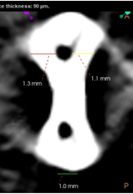
Measurement Before canal preparation
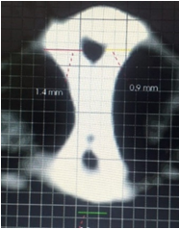
Measurement after canal preparation

Discussion:
Endodontic cleaning and shaping are challenging procedures due to the variations in root canal anatomy. Root canal shaping influences the subsequent steps of root canal irrigation and filling. Ideally canal shaping should create a continuous tapered preparation from crown to apex sustaining actual path and keeping the foramen size as small as possible. ¹ Transportation is most common mishap during instrumentation of curved canals. Transportation in the apex of the root canal promotes harbouring of debris and residual microorganisms resulting in insufficient debridement of the canal. ⁷ Hence, this study was conducted to measure and compare canal transportation and centering ratio of WaveOne GOLD, Reciproc Blue and TwoShape file systems using Cone Beam Computed Tomography and exporting images into Adobe photoshop software.
In the present study, the comparison of canal transportation between the study groups at various levels and the results are statistically insignificant. There were no significant differences in canal transportation between groups at any of the levels studied. However, less canal transportation was observed with Wave One Gold at levels 3 and 5 (.075, 0.077, respectively) followed by Reciproc Blue (0.078, 0.098, at levels 3 and 5, respectively) and 2 Shape (0.149, 0.188 at levels 3 and 5, respectively). At level 7, less canal transportation was observed in the 2 Shape group (0.091) compared to Wave One Gold (0.093) and Reciproc Blue (0.1). A study by HAGE W, Zogheib C, Bukiet F et al (2020) conducted an invitro study to evaluate canal shaping ability of Reciproc and RB systems in curved roots, prior use of PathFile by using CBCT. One twenty curved root canals from mandibular and maxillary premolars were taken and divided into four groups n=30. Reciproc R 25 group; PathFile+ Reciproc 25 group; Reciproc blue group; PathFile + Reciproc blue 25. Samples were mounted in silicon impression material and subjected to CBCT imaging at 3, 9,15mm pre and post operatively. There was less transportation and good centering ability when path file was used in Reciproc blue 25 and Reciproc 25. ⁸
In the present study, intra group comparison revealed that 2 shape at level 5 showed more centering ability (0.662) however 2 Shape showed least centering ability at 7mm (0.512). Reciproc blue at level 5 showed more centering ability (0.754) however Reciproc blue showed least centering ability at 3mm (0.484). WaveOne Gold at level 5 showed more centering ability (0.77), and least centering ability was shown at 3mm (0.528). Elsaka, S.E. Elnaghy, A.M et al (2017)15 conducted a study and compared Torsional and bending resistance of WOG, Reciproc and Twisted adaptive files. Twenty instruments per group were included in each group. WaveOne Gold group, Reciproc group and Twisted file adaptive. In WOG group primary file size 25, with taper of 0.07. In Reciproc group, size of 25 with taper 0.08. In Twisted file adaptive, size of 25 with taper 0.08 was used. Stereo microscope 20x magnification was used to examine the instruments before conducting the test. Torsional resistance was tested on custom metal blocks containing cubical hole(3mmx3mmx3mm). 3mm tip of each instrument was secured tightly by filling the mould with light cured resin composite. A torsion tester was applied at 2 rpm rotation until the instrument fractured and maximum torsional load was noted. Universal testing machine was used to test bending resistance. Electron microscopy was used to examine the fractured instruments. The fractured instruments were fixed on metallic stub and evaluated at different magnifications. (250 ×500 × and 1000 x). They concluded that WaveOne Gold had higher resistance to torsional stress and flexibility when compared to Twisted file adaptive files and Reciproc. ⁹ Kataiaa Mohamed Medat, Roshdy Nehal Nabil, Nagy Mohamed Mokhtar (2018) 17 evaluated and compared shaping abilities of WOG, Reciproc Blue in reciprocation and counter clockwise rotation, and also time attained for full working length. Fifty- Two canals in resin blocks were mounted with angle of curvature 30 degree, working length was set at 16mm and divided into 4 groups: Reciproc Blue - Reciprocation group, Reciproc Blue - counter clock wise rotation group, WaveOne gold – Reciprocation group and WaveOne gold - Counter clock wise rotation group. Pre, post instrumentation images were standardized and adobe photoshop was used to superimpose pre and post instrumentation images. Digital chronometer used to record time. They concluded that Shaping ability of Wave One Gold was improved, there was less canal transportation when compared to Reciproc blue. No statistical significance was found among 4 groups. Wave One Gold prepared in shorter time than Reciproc blue instrument. ¹⁰ Some degree of transportation may occur which leads to ledge formation in curved canals. Precurving the stainless-steel files reduces the rotational movement inside the curved canals. Flexibility and super elasticity of NiTi files reduce the iatrogenic errors in curved canals. The advent of NITI rotary instruments enabled more rapid, rounder, and conservative canal shaping techniques while preserving the canal curvature. For sake of increased safety and ease of use while achieving more predictable canal preparation, changes in instrument designs, shape, and physical properties have been developed. Canal preparation with rotary NiTi systems remain significantly well centred in canal space, resulting in less transportation than hand filing with Stainless steel files. ¹¹ WaveOne Gold (Dentsply Maillefer) reciprocating files manufactured by post-manufacturing heat process through new phasetransition, martensite and austenite which produces file with property of superelasticity. It gives gold finish to file with increased mechanical properties. WOG Primary file has fifty percent resistance to cyclic fatigue, eighty percent flexible and twenty three percent effective than original Wave One Primary files. It is characterized with parallelogram off-centred cross-section, its design limits engaging the file and dentin with one or two contact points at any cross-section. It subsequently reduces the screw-effect and taper lock, improving safety and cutting efficiency, and providing more space around the instrument to remove debris coronally while preparing the canal. The files are also manufactured with an ogival (pointed arch), roundly tapered, and semiactive guiding tip to ensure a secured and reproducible glide path. ¹² Two Shape is a sequence file, works in continuous rotation which had been heat treated by T Wire technology. The flexibility of these instruments increases the comfort and negotiates the curvatures, which return to their initial shape after use. It has an asymmetrical cross-section; it offers superior cleaning of root canal walls with two main and one secondary cutting edge and non- cutting safety tip for better negotiation of canal curvatures. These edges increase the cutting efficiency of the file and improves debris removal. T-wire technology, enhances the flexibility of instruments and fracture resistance. Two-Shape system consists of TS1 (25/0.04), TS2 (25/0.06), F35 (35/0.06), and F40 (40/0.04) files. ¹³
Conclusion:
WaveOne Gold showed better centering and less canal transportation than Reciproc blue and 2 Shape. Least centering and more transportation was observed with 2 Shape file system.
References:
- Sharma S, Rajkumar V, Sarin S, Sarin S, Chugh CS, Kaur H. Biomechanical preparation of teeth: A comprehensive review HECS. Int J Com Health and Med Res. 2017;3(3):89-92.
- Waplington M and McRobert A.S. Shaping the root canal system. Br. Dent. J. 2014; 216(6): 293-7
- Van der Vyver PJ, Jonker C. Reciprocating instruments in Endodontics: a review of the literature. S. Afr. dent. j. 2014; 69(9): 404-9.
- Webber J. Shaping canals with confidence: WaveOne GOLD single-file reciprocating system. Int Dent Afr Ed. 2016; 6(3):6-17.
- Uslu G, Özyürek T et al. Cyclic fatigue resistance of 2Shape, Twisted File and EndoSequence Xpress nickel-titanium rotary files at intracanal temperature. J Dent Res Dent Clin Dent Prospects.2018; 12(4):283-7.
- Singh S, Gupta T, Pandey V, Singhania H, Pandey P, Gangavane S. Shaping Ability of Twoshape and ProTaper Gold Files by using ConeBeam Computed Tomography. J.Contemp. Dent. Pract. 2019; 20(3): 330-4.
- Sinha D J, Rawat G, Chaudary A, Pratap Singh U, Goel S, Jaiswal N. “comparative evaluation of canal transportation between three singlefile systems Hyflex EDM, S- ONE and Neolix Neoniti, using cone beam computed tomography (CBCT) an invitro study”. Int. j. Curr. Res. 2020; 12(7): 12566-9.
- Hage W, Zogheib C, Bukiet F, Sfeir G, Khalil I, Gergi R, Naaman A. Canal Transportation and Centring Ability of Reciproc and Reciproc Blue with or Without Use of Glide Path Instruments: A CBCT Study. Eur Endod J 2020; 5(2): 118-22
- Elsaka SE, Elnaghy AM, Badr A.E. Torsional and bending resistance of WaveOne Gold, Reciproc and twisted file adaptive instruments. Int. Endod. J. 2017; 50(11):1077–83
- Kataia MM, Roshdy NN, Nagy MM. Comparative analysis of canal transportation using reciproc blue and wave One Gold in simulated root canals using different kinematics. Futur. Dent. J. 2018; 4(2): 156–9.
- Kuzekanani M. Nickel–Titanium rotary instruments: Development of the single-file systems. J Int Soc Prevent Communit Dent 2018;8(5):386- 90.
- Van der Vyver P and Vorster M. WaveOne® Gold reciprocating instruments: clinical application in the private practice: Part 1. S. Afr. dent. J. 2018; 7(4): 6-19.
- Faisal I, Saif R, Alsulaiman M, Natto Z S. Shaping ability of 2Shape and NeoNiTi rotary instruments in preparation of curved canals using micro-computed tomography. BMC Oral Health. 2021; 21(1):1-11.

